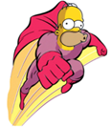
DIRECTIONS for GATHERING PICTURES prior to GIMP ASSIGNMENT #1

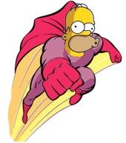

- Open your computer’s internet connection and search for pictures using Google Images.

- Whenever possible, try to use transparent GIF images because it will save you a great deal of work. JPEG images have a white background which is more difficult to erase when editing pictures.

- NOTE: You may use www.convertmyimage.com in order to convert jpegs and png images to gif images. This does not necessarily make the background transparent, however.

- Find the following pictures (or similar) and save each to your flash drive folder:

- Two or three City Skylines at night
- Two or three Full Moons (or any other planets such as Saturn, etc)
- Two or three Flying Superheroes (male or female)
- Two or three cartoon characters (Peter Griffin, Stewie, Homer Simpson, or similar)
- Two or three Spongebob Squarepants face
- Two or three fireworks exploding in the sky

- Make a folder on your flash drive and name it GIMP Images. Be sure to save all of the images you found today, in this folder.

