Your Name BLUE A 09-26-14
GOOGLE EARTH ONE
Name and Location – City, State, Country | Google Earth Image of Location
Lincoln Middle School  Lincoln Rhode Island | 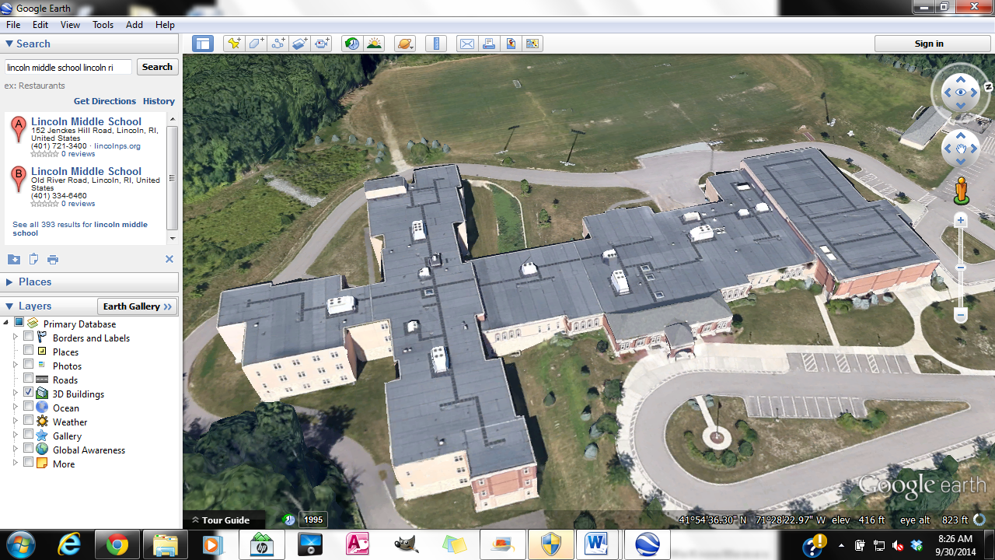
Lincoln High School Lincoln Rhode Island
Your House
The Narragansett Towers Narragansett, RI
The Rhode Island State House Providence, RI
Block Island, RI
The Newport Bridge Newport, RI
The Dunkin’ Donuts Civic Center (Dunk) Providence, RI
Slater Mill Pawtucket, RI
The Newport Breakers Newport, RI
The Eiffel Tower Paris, France
The White House Washington, DC
The Grand Canyon Phoenix, AZ
The Pentagon Arlington, VA
The Leaning Tower of Pisa Pisa, Italy
The Taj Mahal Agra, India
The Roman Coliseum Rome, Italy
The Great Wall of China , China
The Sydney Opera House Sydney, Australia
The London Tower Bridge London, England
The Kremlin Moscow, Russia
The Empire State Building New York, NY
Golden Gate Bridge San Francisco, CA
Space Mountain, Orlando FL

